Modeling and Analysis of Bridge Vibrations

Alexandru Beloiu

**Introduction**

On July 1st, 1940, the Tacoma Narrows Bridge open for public use. Four months later the bridge collapsed due to 42 mph winds, forever cementing it in history as an engineering failure to learn from. After first learning about the Tacoma bridge collapse in a scientific documentary [1,2], I became curious on how such a massive structure made of concrete and steel could experience large oscillations under relatively small wind speed, leading me to begin research on how such a phenomenon could occur. This led to me discovering the concept of resonance: where the natural frequency of the object matches the excitation frequency of an external force. I became interested on developing a mathematical model of the bridge and find a way to reduce displacement when resonance occurs.

This investigation aims to develop a mathematical model of a bridge that takes into account stiffness of the bridge, mass, natural frequency, damping, external excitation force, and excitation frequency of the system. The objective is to investigate the bridge vibrations for different bridge parameters (stiffness, damping, natural frequency) and excitation parameters (force magnitude and excitation frequency) to provide a better understanding of resonance and how architects and engineers can better design bridges to avoid excessive vibrations that can lead to bridge collapse.

**Theory**

Bridge vibrations can be caused by excitation forces generated by the wind, or by dynamic forces resulting from vehicles and pedestrians passing the bridge. The natural frequency is the speed at which a structure vibrates freely when excited by a force. When the frequency of the force and the natural frequency of the structure are close to each other, resonances occur. Resonance results in large amplitudes of vibration in the bridge which can lead to the bridge collapse. The reason the Tacoma Narrows Bridge collapsed was due to the frequency of the excitation force of the win matching the natural frequency of the bridge, causing the bridge to oscillate with large amplitudes and causing a break in the structure.

All bodies have stiffness and damping, meaning that we can approximate the mechanical system of a medium-size bridge as a mass-spring-damper system as shown on Figure 1. This will allow us to derive an equation for our model analytically without the aid of programs such as MATLAB.



**Figure 1** Mathematical model of a bridge using a single degree of freedom mass-spring-damper system

The spring represents the support of the bridge and the value (spring constant) which represents the stiffness of the spring will represent the stiffness of the bridge. The damper will work the same as it does in bridges, reducing the vibration of the mass. The block of mass will act as the main platform of a medium-size bridge in this investigation. This model will have a single degree of freedom on the vertical axis. The excitation force given by wind’s air waves or movement of people and cars on the bridge is considered a sinusoidal force with magnitude and frequency .

**Free Body Diagram**

In order to derive the equations of motion of the bridge, we use the Free Body Diagram as shown in Figure 2 and Newton’s Second Law.

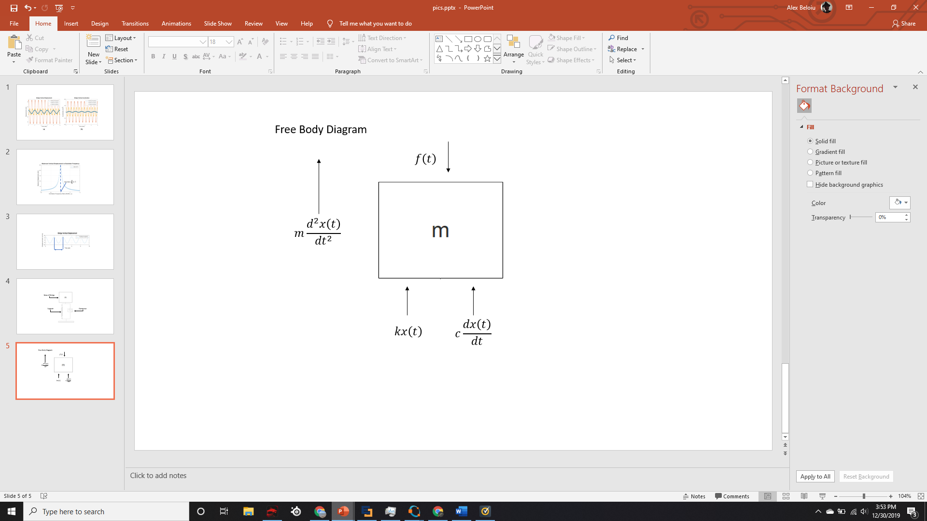  
**Figure 2** Free Body Diagram of the bridge modeled as a mass-spring-damper system excited by a sinusoidal external force

Symbols and notations:

– Mass of the bridge

– Spring constant (stiffness of the bridge)

– Displacement of the bridge as a function of time

– Velocity of the bridge (time derivative of the displacement)

– Acceleration of the bridge (time derivative of velocity or 2nd derivative of displacement)

– Viscous damping coefficient

– Damping ratio

*–* Natural frequency of the bridge

– Total force acting on the bridge

– Excitation frequency of the external force

– Magnitude of the external force (excitation) acting on the bridge

**Step 1: Newton’s Second Law**

Newton’s Second Law of Motion states that summation of forces acting on an object is equal to the mass times acceleration of the object [4]. From the Free Body Diagram (Figure 2), Newton’s Second Low can be written as

. (1)

There are three forces acting on the system:

* Elastic Force – the force of the spring exerted on the system given by acting opposite to the excitation force.
* Damping Force – the force of the dampener exerted on the system given by acting opposite to the excitation force. represents the velocity of the system as a function of time.
* Excitation Force – In this investigation, we will assume that the force exerted on the bridge is modeled by a cosine graph in order to make the complex problem easier to understand. The external force exerted on the system given by acting upwards or downwards depending on the point of time on the cosine curve.

The reason we use the derivative and double derivative of displacement to represent velocity and acceleration, respectively, is to relate the velocity and acceleration to displacement over time and to represent the rate of change in displacement over time as it is not constant. We can show this on our model by creating a free-body diagram using Edraw (Figure 2)

In our first step, we want to derive a general equation that can be used to model this problem. Considering forces acting on the mass *m*, equation (1) becomes:

(2)

Equation (2) is a second order, non-homogenous ordinary differential equation with constant coefficient which describe the time dependent motion of the mass-spring-damper system [3]. The “second-order” designation is because contains second derivative of the displacement. The “non-homogenous” designation is because the right-hand side is non-zero. The coefficient *m, k* and *c* are constant meaning they do not depend on time.

Now we want to put this equation in terms of frequency and declare a force function to act upon the system. We will use the aforementioned as our function to represent force over time.

(3)

To put the equation in terms of frequency, we want to divide the whole equation by .

(4)

From [3], we know that natural frequency of the system is represented by the equation and the damping ratio is represented by so equation (4) becomes:

(5)

**Step 2: Analytical Solution**

Our end goal for solving equation (5) is to solve for or displacement over time. The general solution of equation (5) is [3]

(6)

As we solve this differential equation for displacement, we have to take in account the two parts of the differential equation, the complementary solution (transient-state) and the particular solution (steady-state) solution which, when both added together, form the total response of the system . However, in the case of our bridge problem, the transient-state solution is not imperative and it can be ignored as the transient-state only takes in account the initial displacement of the bridge when a force is acted upon it, eventually leveling out and becoming zero due to damping. Since we care about the stability of the bridge over a long period of time, the transient solution can be neglected so we can equate to zero [3].

Since we have our equation as a cosine function , we will assume that the particular solution (steady-state) of the differential equation will contain both sine and cosine and be in the form of with and being constants that we need to solve for.

(7)

Since we know that then and .

We can use this information and take the derivative and double derivative of and plug it into the general equation (7) to solve for and .

Now we plug these values into the general differential equation (5):

In order to simplify the equation, we want to group together the sine and cosine functions:

(8)

Since we know that this equation has to be valid for all times t, the coefficients of and must equal zero.

Solving for Equation 1:

**Equation 1:** =

Solving for Equation 2:

**Equation 2:**

So now we make a system of equations using the two equations we just made:

(9)

In order to solve the system of equations, we will use the elimination method to isolate and .

First, we will multiply Equation 1 by and Equation 2 by with the goal of canceling out by adding the two equations together.

After isolating out , we want to solve for by putting it on the left side alone.

Now we need to solve for by doing the same process again, this time canceling out . We will multiply Equation 1 by and Equation 2 by and add the two equations together.

After isolating out , we want to solve for by putting it on the left side alone.

**Step 3: Plugging it back in to find the Particular Solution**

Recall that the particular solution can be modeled by the equation

and since we are ignoring the complementary solution due to its negligible effect on the physical interactions of a large-scale bridge, .

Our last step to find is to plug in the and constants into the particular solution, giving us our final answer as follows

(10)

Equation (10) represents the particular (steady-state) solution of the equation of motion (5) of the bridge.

**Numerical Solution**

Now that we have created an equation to model the bridge oscillations under external sinusoidal excitation, we are able to run numerical tests to observe how force interactions on the bridge affect the bridge with different parameters in place. In order to run these tests, I created an MATLAB program to solve equation (10) to test different parameters and create graphs. I will analyze the bridge vertical displacement, velocity, and acceleration over time for different force values exerted on it, along the maximum vertical displacement for different values. Below are the parameters I will be using. The results I gather from these tests will allow me to identify the main problem in bridges and change parameters that will result in the most stable bridge.

**Table 1** Parameters used in the numerical simulations

|  |  |  |
| --- | --- | --- |
| Parameters | Value | Explanation |
| m, kg | 100,000 | Bridge mass and stiffness was selected to obtain a bridge natural frequency of approximately 1Hz which is found in reference [3]. |
| k, N/m | 4,000,000 |
|  | 0.01 to 0.1 | Damping ratiowas selected small to represent an underdamped system [3]. |
|  | 10, 20, 30 | Excitation force magnitude was selected assuming typical weight of a vehicle: 1,000…3,000 kg. |
|  | to | Excitation frequency values were selected to simulate a frequency range below and under the bridge natural frequency of 1 Hz. |

Figure 3 shows the vertical displacement of the bridge for an excitation with magnitude of and frequency of .

By looking closer at the displacement function, we are able to distinguish its period, amplitude, and frequency. The period of the equation can be found using the equation and is has the units of seconds. In this case the period of is 2 seconds and the amplitude is 6.666mm.

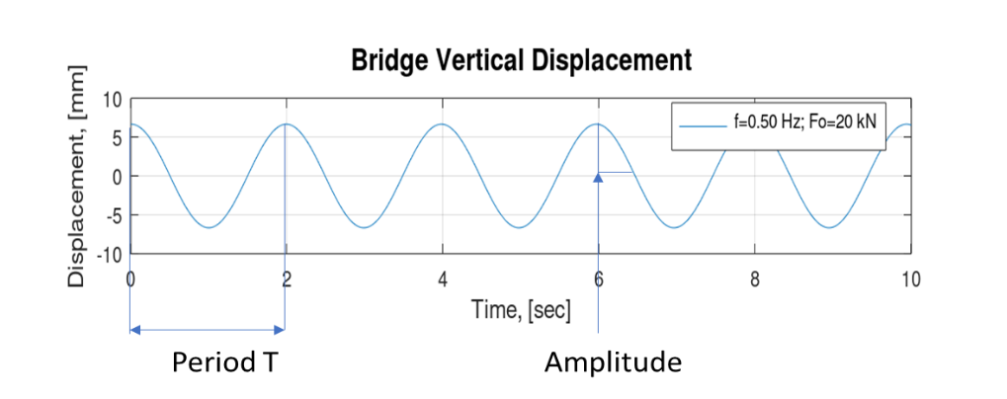

**Figure 3** Steady-state vertical displacement versus time assuming and excitation

In order to analyze changes in velocity and acceleration over time in our bridge model, we need to take the derivative and double-derivative of the displacement function .

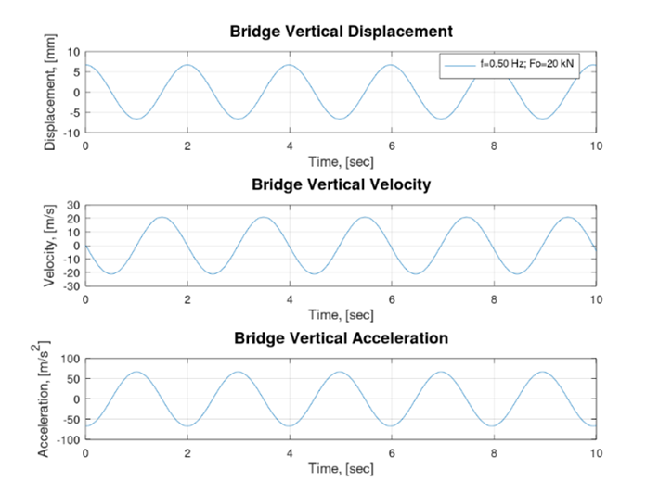

**Figure 4** Vertical displacement, velocity and acceleration versus time assuming and excitation

Figure 5 shows the displacement and acceleration versus time for three values of the excitation frequency . It is interesting to note that the amplitude of oscillations is significantly different for the three values of the excitation while all other parameters are maintained constant. This shows that the frequency of the exciting force is the main parameter that leads to the large oscillations and eventual destruction of the bridge. The maximum displacement at the excitation frequency of is much greater than the displacement at (see Figure 5 and Table 2). This is because the excitation frequency is close to the natural frequency of the bridge which was selected to be .

The results suggest that the amplitude of the response (displacement, velocity, acceleration) are large if excitation frequency is close or equal to the natural frequency of the bridge. If the frequency of excitation is equal to the natural frequency of the bridge, the magnitude of oscillations to increase to “infinity”. In practice, the magnitude of the bridge oscillations is finite because of damping.

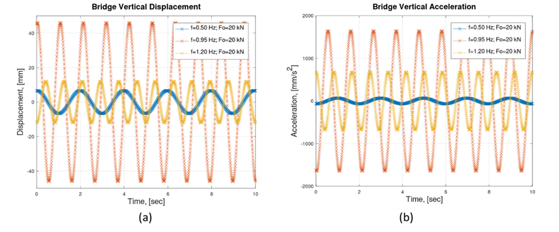

**Figure 5** Bridge vertical displacement (a) and vertical acceleration (b) versus time for three values of excitation frequency

**Table 2** Maximum displacement and maximum acceleration for three values of the excitation frequency

|  |  |  |
| --- | --- | --- |
| Excitation Frequency | Maximum Displacement | Maximum Acceleration |
|  | 6.666 mm | 66.6 |
|  | 46.027 mm | 1644.1 |
|  | 11.997mm | 679.53 |

In order to better understand the effect of excitation frequency, I solved the equation of motion (10) for various values of excitation frequency and represented the maximum displacement versus (excitation frequency ratio) for each of the simulation as shown in Figure 6.

Graphing displacement of the bridge over the excitation frequency ratio shows us that as the ratio approaches 1, the displacement of the bridge increases exponentially with the point of resonance, when , being the point of maximum displacement. This essentially means that if an external force is acted upon the bridge with a frequency close to the natural frequency of the bridge, the bridge will begin to oscillate with high amplitude of displacement due to resonance.

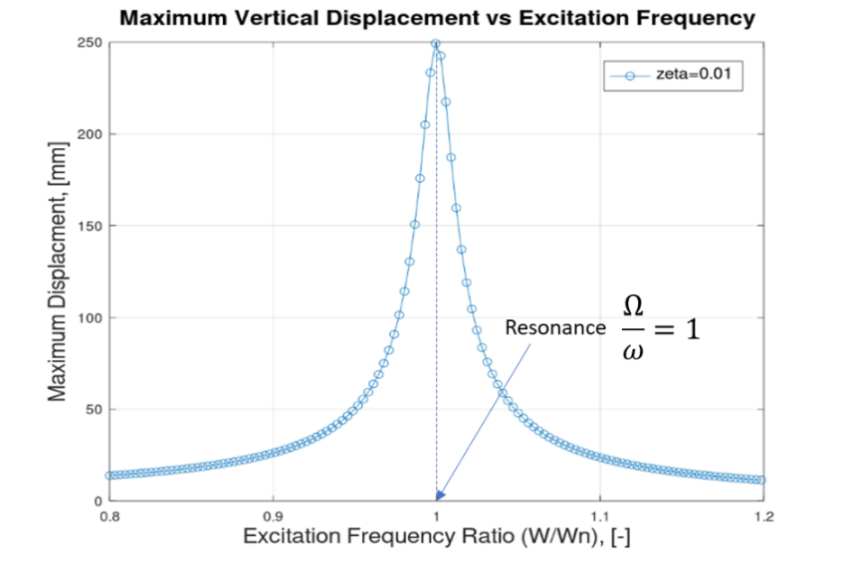

**Figure 6** Maximum displacement versus ratio and damping ratio

Figure 7 shows the maximum vertical displacement versus excitation frequency ratio for various values of damping factor . It can be noted that by increasing damping, the maximum displacement decreases even at resonance. This is because more energy is dissipated by the dampers.

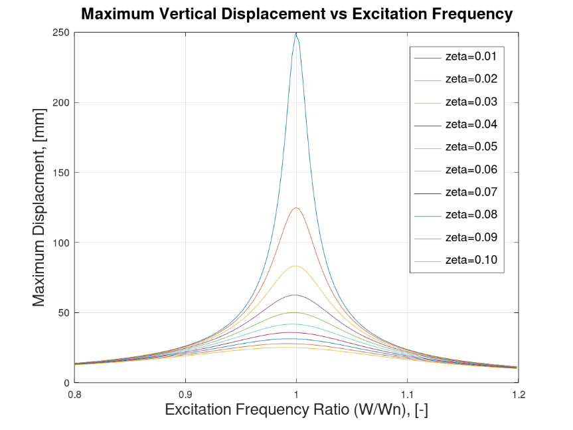

**Figure 7** Maximum vertical displacement versus excitation frequency ratio for various values of damping factor

Referring back to the Tacoma Narrows Bridge, the frequency of the wind matched the natural frequency of the bridge, causing it to reach resonance and oscillate noticeably. In order to avoid resonance, one option would be to design a bridge with very high stiffness and low mass so that natural frequency is high and above excitation frequency of the external forces. A more practical approach is to assure that the bridge has sufficient damping by using dampers so that amplitude of oscillations is minimized even if the bridge is excited at resonance.

**Conclusion**

Putting it all together, we are able to apply the knowledge displayed from our graphs to identify the concept of resonance as the major problem hindering bridge designs with the solution being the implementation of dampers with higher dampening values. Our results show that a bridge with damping ratio has a maximum displacement of 25.019 mm at resonance while a bridge with has a much bigger maximum displacement of 249.44mm. These results make sense since damping is used to reduce vibrations at resonance and does not have a large effect on displacement away from resonance, as seen in Figure 7. These results are extremely important and provide us with a solution to prevent bridges from collapsing when an external force has the same excitation frequency as the bridge’s natural frequency, which is to include larger dampeners in bridges.

However, the results found in this experiment can be expanded upon greatly as it only takes in account vertical forces caused by wind or objects on top of the bridge, not taking in account any horizontal forces caused by wind. By increasing the number of the degrees of freedom we could derive a system of equations that take into account both vertical and horizontal forces and motions. This simplified model provides a simple way to show how vertical component of forces generated by wind or soldiers marching or cars driving on a bridge can affect the overall stability of the bridge. This equation would be extremely important in fields such as civil-engineering, allowing these engineers to model theoretical situations, stress test these models, and make improvements to the bridge design, ensuring that the infamous Tacoma Narrows Bridge disaster never happens again.

**References**

1. Elliott, Barney, director. Tacoma Narrows Bridge Collapse. The Camera Shop, 1940.

2. Tyrell, William. “Engineering Disasters: Tacoma Narrows Bridge Collapse (1940).” *EngineeringClicks*, 4 Oct. 2017, www.engineeringclicks.com/tacoma-narrows-bridge-collapse/.

3. Meirovitch, L., Elements of Vibration Analysis, 2nd edition, McGraw-Hill, New York, 1986

4. Jewett, Serway, Physics for Scientists and Engineers, 6th edition, Brooks/Cole – Thomson Learning, 2004

5. Eaton, John W. “GNU Octave (Version 5.1.0).” *Top (GNU Octave (Version 5.1.0))*, 2018, octave.org/doc/interpreter/index.html.

**APPENDIX:** MATLAB code used to solve equation of motion and generate plots

% This MATLAB program solve the equation of motion and create plots for various values of excitation frequency

t = 0:0.01:10; % Simulation time

% Bridge parameters

m=100000; % Bridge mass [kg]

zeta=0.01; % Damping factor [-]

k=4000000; % Bridge stiffness [N/m]

Wn=sqrt(k/m); % Angular natural frequency [rad/s]

fn=Wn/(2*pi) % Natural frequency [Hz]. Note that f[Hz]=W/2*pi

% Excitation parameters

Fo=20000; % Excitation force acting on the bridge [N]

W=[0.5*Wn 0.945*Wn 1.19*Wn]; % Excitation frequency of the force acting on the bridge [rad/s]

for jzeta=1:length(zeta)

for j=1:length(W)

% Steady state solution - Displacement

x{jzeta}(j,:)=(((Wn^2-W(j)^2)*Fo/m)/((Wn^2-W(j)^2)^2+(2*zeta(jzeta)*W(j)*Wn).^2))*cos(W(j)*t)+...

(((2*zeta(jzeta)*W(j)*Wn)*Fo/m)/((Wn^2-W(j)^2)^2+(2*zeta(jzeta)*W(j)*Wn)^2))*sin(W(j)*t);

dx{jzeta}(j,:)=(((Wn^2-W(j)^2)*Fo/m)/((Wn^2-W(j)^2)^2+(2*zeta(jzeta)*W(j)*Wn).^2))*(-W(j))*sin(W(j)*t)+...

(((2*zeta(jzeta)*W(j)*Wn)*Fo/m)/((Wn^2-W(j)^2)^2+(2*zeta(jzeta)*W(j)*Wn)^2))*(W(j))*cos(W(j)*t);

ddx{jzeta}(j,:)=(((Wn^2-W(j)^2)*Fo/m)/((Wn^2-W(j)^2)^2+(2*zeta(jzeta)*W(j)*Wn).^2))*(-W(j)^2)*cos(W(j)*t)+...

(((2*zeta(jzeta)*W(j)*Wn)*Fo/m)/((Wn^2-W(j)^2)^2+(2*zeta(jzeta)*W(j)*Wn)^2))*(-W(j)^2)*sin(W(j)*t);

legend_W{j} = sprintf('f=%2.2f Hz; Fo=20 kN\n', W(j)/(2*pi));

xm{jzeta}(j,:) = max(x{jzeta}(j,:));

end

legend_zeta{jzeta}=sprintf('zeta=%2.2f\n', zeta(jzeta));

end

% Plot displacement,velocity, acceleration vs time for one value of omega, zeta...

figure

subplot(3,1,1)

plot(t,1000*x{1}(1,:))

grid on

xlabel('Time, [sec]',"FontSize",12)

ylabel('Displacement, [mm]',"FontSize",12)

h=legend(legend_W{})

%set (h, "fontsize", 12);

subplot(3,1,2)

plot(t,1000*dx{1}(1,:)) title('Bridge Vertical Displacement',"FontSize",14)

grid on

xlabel('Time, [sec]',"FontSize",12)

ylabel('Velocity, [m/s]',"FontSize",12)

title('Bridge Vertical Velocity',"FontSize",14)

%h=legend(legend_W{})

%set (h, "fontsize", 12);

subplot(3,1,3)

plot(t,1000*ddx{1}(1,:))

grid on

xlabel('Time, [sec]',"FontSize",12)

ylabel('Acceleration, [m/s^2]',"FontSize",12)

title('Bridge Vertical Acceleration',"FontSize",14)

%h=legend(legend_W{})

%set (h, "fontsize",8);

filenam = sprintf('Disp_Velo_Acc_Vs_Time zeta=%1.2f Fo=%6.0f k=%9.0f.png',zeta(jzeta), Fo, k)

saveas(gcf,filenam,'png')

% Plot displacement vs time for 3 values of omega

figure

plot(t,1000*x{1}(),'-x')

grid on

xlabel('Time, [sec]',"FontSize",16)

ylabel('Displacement, [mm]',"FontSize",16)

ylim([-50 50])

title('Bridge Vertical Displacement',"FontSize",16)

h=legend(legend_W{})

set (h, "fontsize", 12);

filenam = sprintf('Disp_Vs_Time_various_omega zeta=%1.2f Fo=%6.0f k=%9.0f.png',zeta(jzeta), Fo, k)

saveas(gcf,filenam,'png')

% Plot acceleration vs time for 3 values of omega

figure

plot(t,1000*ddx{1}(),'-x')

grid on

xlabel('Time, [sec]',"FontSize",16)

ylabel('Acceleration, [m/s^2]',"FontSize",16)

title('Bridge Vertical Acceleration',"FontSize",16)

h=legend(legend_W{})

set (h, "fontsize", 12);

filenam = sprintf('Acc_Vs_Time_various_omega zeta=%1.2f Fo=%6.0f k=%9.0f.png',zeta(jzeta), Fo, k)

saveas(gcf,filenam,'png')